Internal |  |  |  |  |  |  |  |  |  | External
Category | Module | 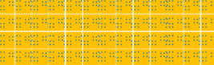  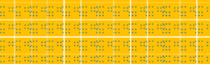  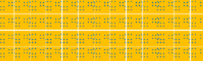  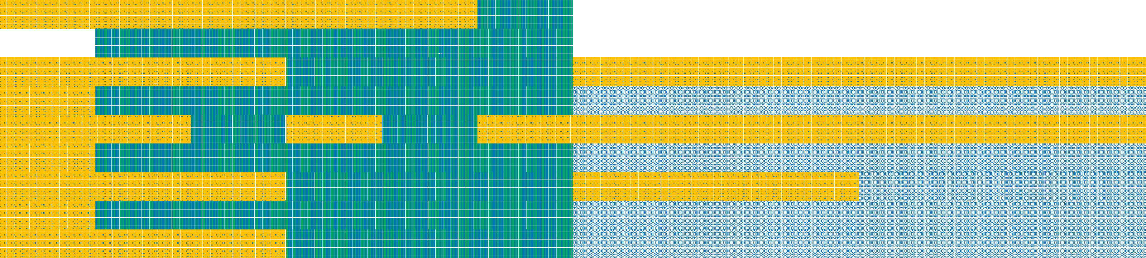  Read Only | Case Management | Program Administration | Case Management  & Shelter | Program Administration & Shelter | Shelter Supervisor | Read Only | Case Management | Program Administration | Case Management  & Shelter | Program Administration & Shelter | Shelter Supervisor
Administration | Rooms & Beds Management |  |  |  |  |  | Level 2
Administration | User Management |  |  |  |  |  | Level 2
Assessments | SPDAT | Level 1 | Level 3 | Level 3 | Level 3 | Level 3 | Level 3 | Level 1 | Level 1 | Level 1 | Level 1 | Level 1 | Level 1
Client Information | Client Details | Level 1 | Level 4 | Level 4 | Level 4 | Level 4 | Level 4 | Level 2 | Level 2 | Level 2 | Level 2 | Level 2 | Level 2
Client Information | Consent | Level 1 | Level 3 | Level 3 | Level 3 | Level 3 | Level 3 | Level 2 | Level 2 | Level 2 | Level 2 | Level 2 | Level 2
Client Information | Contacts | Level 1 | Level 4 | Level 4 | Level 4 | Level 4 | Level 4 | Level 2 | Level 2 | Level 2 | Level 2 | Level 2 | Level 2
Client Information | Documents | Level 1 | Level 3 | Level 3 | Level 3 | Level 3 | Level 3 | Level 2 | Level 2 | Level 2 | Level 2 | Level 2 | Level 2
Client Information | Family | Level 1 | Level 3 | Level 3 | Level 3 | Level 3 | Level 3 | Level 2 | Level 2 | Level 2 | Level 2 | Level 2 | Level 2
Client Information | Financial Profile | Level 1 | Level 3 | Level 3 | Level 3 | Level 3 | Level 3 | Level 2 | Level 2 | Level 2 | Level 2 | Level 2 | Level 2
Client Information | Housing History | Level 1 | Level 4 | Level 4 | Level 4 | Level 4 | Level 4 | Level 2 | Level 2 | Level 2 | Level 2 | Level 2 | Level 2
Communications | Bulletins | Level 1 | Level 1 | Level 1 | Level 1 | Level 1 | Level 3 |  |  |  |  |  | Level 3
Communications | Messaging |  | Level 3 | Level 3 | Level 3 | Level 3 | Level 3
Client Management | Admissions | Level 1 | Level 1 | Level 1 | Level 3 | Level 3 | Level 3 | Level 1 | Level 1 | Level 1 | Level 1 | Level 1 | Level 1
Client Management | Calls/Visits Log | Level 1 | Level 3 | Level 3 | Level 3 | Level 3 | Level 3 | Level 2 | Level 2 | Level 2 | Level 2 | Level 2 | Level 2
Client Management | Case Management | Level 1 | Level 1 | Level 3 | Level 1 | Level 3 | Level 1 | Level 1 | Level 1 | Level 1 | Level 1 | Level 1 | Level 1
Client Management | Clients | Level 1 | Level 3 | Level 3 | Level 3 | Level 3 | Level 3 | Level 2 | Level 2 | Level 2 | Level 2 | Level 2 | Level 2
Client Management | Service Restrictions | Level 1 | Level 1 | Level 1 | Level 3 | Level 3 | Level 3 | Level 1 | Level 1 | Level 1 | Level 2 | Level 2 | Level 2
Client Management | Survey | Level 1 | Level 3 | Level 3 | Level 3 | Level 3 | Level 3 | Level 2 | Level 2 | Level 2 | Level 2 | Level 2 | Level 2
Client Management | Turnaways | Level 1 | Level 1 | Level 1 | Level 3 | Level 3 | Level 3 | Level 2 | Level 2 | Level 2 | Level 2 | Level 2 | Level 2
Reports | Report Manager | Level 1 | Level 1 | Level 1 | Level 1 | Level 1 | Level 1
General | Log On | Yes | Yes | Yes | Yes | Yes | Yes | No | No | No | No | No | No
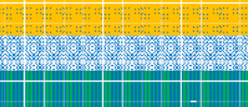
*This resource was generously shared by a HIFIS community, so that others may adapt and use as needed.
 | Level 1 | Display
 | Level 2 | Edit/Display
 | Level 3 | Add/Edit/Display
 | Level 4 | Add/Edit/Delete/Display

