SERVICE SYSTEM MAPPING CASE STUDY:
How a community mapped their service system and what they learned

Reaching Home provides a comprehensive System Mapping Guide and Tool that defines system mapping and outlines the steps for system mapping related to the planning and implementation of Coordinated Access and HIFIS. It also provides a system mapping tool covering each of the steps.

This HIFIS How To: Guidance resource provides a case study about how a community mapped the service system in their community and how it supported their implementation of HIFIS. They describe their process and elaborate on some key lessons learned.

- Community Story: A Case Study
- Lessons Learned
- Mapping in Phases
- User Rights Matrix
- Related System Mapping Resources

CASE STUDY: A COMMUNITY STORY
In order to implement HIFIS in a way that would benefit everyone in Grandview the HIFIS Lead knew they needed to understand both the Service Providers and the work they did in the community. First, we started by inviting everyone we thought would want to be involved to a meeting: shelters, homeless Service Providers, veterans and youth services, health providers.
Many people came to the meeting and there was a lot of excitement generated about HIFIS. Over time, we worked very closely with our Service Providers to learn about every role for the staff that would have access. We spoke with the frontline workers directly and walked through their process, which was informative.
It did take some time to get HIFIS up and running, so many of those original people invited to that meeting have not been part of the roll out. In the end we decided to scale back to starting first with just our shelter providers to capture admission information. We then moved on to case management with those sites before we started adding new Service Providers.
One of the greatest challenges of the system mapping process was overcoming the expectation that it would only take a meeting or two with Service Providers to understand well their workflow and information needs. It took a lot of time, but taking the time needed for everyone to understand and be comfortable meant we were able to configure HIFIS to meet needs. Training was then more effective because everyone understood the positive impact of how we wanted HIFIS to work and be used. It was essential for the HIFIS Lead and administrator to match their workflow to the HIFIS workflow in order to capture the data needed.
In the beginning, we didn’t try to use every module and function of HIFIS from the beginning, although recently, we decided to adjust our approach to add more modules. We walked through capturing diversion in HIFIS with the frontline workers who provide the service. Their feedback was valuable to helping review the data we need from the program.
While the system mapping process was time consuming and challenging, in the end it may have saved us time. Many of the questions explored in the system mapping sessions were relevant to these other key areas of implementation, such as setting up governance, configuration of HIFIS and training. System mapping gave everyone a better sense of HIFIS implementation and the benefits it would bring. While we learned many things we would have done differently, we do recommend every community map their service system early on in their Coordinated Access and/or HIFIS implementation.

LESSONS LEARNED
Experienced HIFIS Leads outline and describe some of the key lessons learned in this section.

- Start small
- Get to know the workflow (day-to-day tasks) of Service Providers
- Know what information is needed
- Include Service Providers and access point workers
- It will take longer than you think

Lesson 1 – Start small
Communities will approach system mapping differently depending on a number of factors including size and number of Service Providers involved. Communities with experience implementing HIFIS recommend that you focus on operational needs first, such as just your shelters. The main reasons for starting small are:
- It will be easier to manage (i.e. communications, meetings, training, expectations);
- You will be able to keep key Service Providers engaged and informed; and therefore,
- It will be easier to get their support, then you can leverage them to engage others when you expand your scope;
- You will be able to implement lessons learned more easily when you expand to the next phase.
Some experienced communities recommend directly asking Service Providers how much they want to be involved in the process. Getting the right people on board and engaged early on will build commitment and confidence that can positively influence your next phases.

Lesson 2 – Get to know the workflow (day-to-day tasks) of Service Providers
In order to configure HIFIS to meet the needs of the users, it will be essential to understand the services your Service Providers offer and what are their workflow. Meeting with your Service Providers to map out and understand the role of their users is essential for configuring HIFIS, as well as setting User Rights. By engaging Service Providers in this process, it can help manage their expectations and gain their support for both the process and expansion phases for HIFIS in the community.

Lesson 3 - Know what information is needed
It is important to know what data your Service Providers need to capture as well as how they will use that data to support their clients, and report to boards and funders. Consult your Service Providers to get a good understanding of what information Service Providers want to collect and what module in HIFIS will support the information. It is vitally important you have the reporting mechanisms in place so Service Providers are able to report on these data collection points. Often Service Providers will transition all of their data collection to HIFIS, which means they require greater access to the information they are inputting. Coming up with a pathway for them to request a new report or even defining what you, as the System Manager, are willing to assist on reporting will keep expectations in check.

Lesson 4 - Include the Service Providers throughout the journey
When big system changes are implemented, such as Coordinated Access or adding new technology like HIFIS, workflows will change. Having a good understanding of the value of these changes particularly if the changes do not make their jobs easier, will be essential for staff. Finding a way to establish buy-in from everyone involved is important. People are more likely to be supportive if you consult and inform them throughout the process. In the case study above the community did so from the beginning. Engaging Service Providers who will contribute to the change continues to be their approach for expanding their implementation.
HIFIS is a flexible tool and can be customized and configured in many ways to meet needs. Be sure not to overwhelm your community members with too many possible options in HIFIS. It can confuse and create expectations. Stick to demonstrating functions they will use.

Lesson 5 – It might take longer than you think
Mapping your community’s service system and workflow will take time. Probably more time than you think. Every community is different; however, it would be optimistic to base your timelines for implementation after just a couple of system mapping meetings. HIFIS Leads with experience note that it can take anywhere from 6 months to two years. Patience and listening, and then being able to demonstrate stakeholder needs in the configuration of HIFIS will help keep your implementation process moving in the right direction.

MAPPING IN PHASES
Communities that have implemented HIFIS recommend mapping your implementation by phases or stages. Rolling out of your implementation will mirror your mapping phases as well. Here are the recommended phases and some guidance for what to consider mapping at each phase.

Phase
1
Start mapping your emergency shelters and outreach. The User Rights Matrix tool (See Section 4) can help communities specify what modules are needed, wishlist, or not needed. Use this to help map out your rollout and help Service Providers get a sense of the direction and scale of roll out they want.
- Make a list of your shelters / outreach organizations.
- Identify which organizations need to be part of phase 1 rollout based on operational needs - who would benefit most?
- Decide who the HIFIS lead/contact within each organization is. Ask them how much they want to be involved in planning.
- Decide what modules are a priority for phase 1 rollout, and which you would like in the future.
- Decide what staff at each shelter/ organization need use HIFIS as of phase 1- don’t assume everyone will.
- Design user rights based on module roll out plan.
- Focus on operational needs in this phase.
- What activities would benefit most from being tracked? Start with the most essential. You will expand as the phases expand. Starting too big will create data entry fatigue and the learning curve for staff will be steep.
Phase
2
Expand to include your other funded programs and partners in HIFIS. Consider your By-Name List/Unique Identifier List when deciding on this group.

- Identify your next phase of partners and programs. This should be the organizations providing daily support to clients. Financial supports, addictions support, mental health supports, housing help organizations that are funded to deliver programs.
- Who can have the most impact by joining the cohort of HIFIS users?
- Do you have any housing/supports dedicated to the By-Name List that could track placements through HIFIS? Consider your housing first programs, transitional housing, supportive housing, rent supplement providers, etc.
- Regarding Funding requirements: take a look at program guidelines and see if all or most can be tracked in HIFIS. Are you a Reaching Home community? Can you use HIFIS data for reporting?
- Do we have a report builder or a plan to get data out of HIFIS when you need to report it?
Phase3
Include any other Service Providers that share clients with you.

- This should include any partners that are not funded, but play a key role in serving people experiencing homelessness.
- Do you have partners that are not strictly homelessness serving, but have a daily need to access HIFIS and add data to it?

Widen your scope beyond the homelessness serving sector such as, social workers at hospital who may discharge to homelessness, nearby correctional facilities who discharge to homelessness. Parole Officers supporting people in your community, community health offices i.e. Nurse Practitioner clinics, etc.
Phase
4

- Who shares your service system goals and can benefit the most from having access to HIFIS?
- Who is most likely to participate if you provide access to HIFIS and training on data entry?

USER RIGHTS MATRIX: AN EXAMPLE
This matrix is a tool that can help during your system mapping phase to track what modules your Service Providers will use or not. Once completed, it can then help you decide the scale of your implementation roll out. For the template version of this tool search the title in the Homelessness Learning Hub.
Figure 1 User Rights Matrix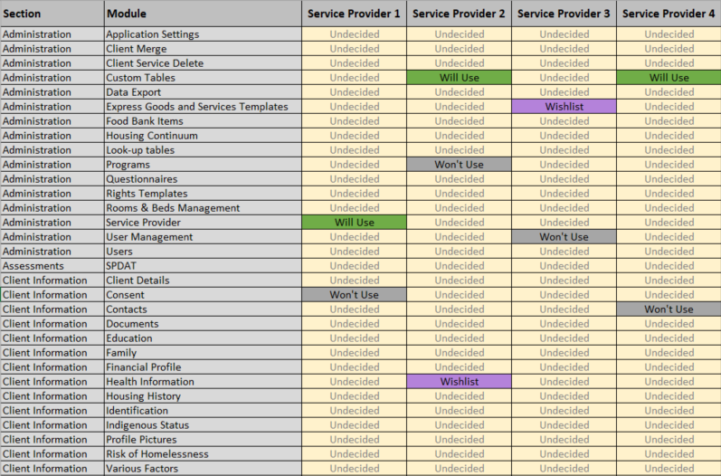

RELATED SYSTEM MAPPING RESOURCES
Some related system mapping resources that explain system mapping in the context of Reaching Home as well as system mapping in general include:
- The Reaching Home System Mapping Guide and Tool found on the Homelessness Learning Hub. This guide and tool is a working version developed for Reaching Home Designated Communities in BC, but relevant for all Reaching Home communities.
- For general resources about system mapping search “System Mapping” on the Homelessness Learning Hub for other related resources.
- If beginning the process before engaging with your stakeholders you could consult the National Service Provider List, 211 or HelpSeeker to populate a list of service providers in your community or the “Start Map Here” tab in the Reaching Home System Mapping Tool.

