Everyone Counts: The 2020 Coordinated Point-in-Time Count

Approaching people when conducting the survey

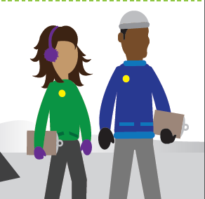
1

Make yourself visible
Make sure that your surveyor identification (badge or button) is visible.
2

Make eye contact first
As you are approaching the individual, introduce yourself and make eye contact. Be friendly and polite.
3

Respect personal space
Begin the script when you reach a comfortable distance. Do not invade the person’s personal space.
4
Mention the purpose early
Mentioning the purpose of the survey early will help to generate interest. You can follow the script, or adapt it, but make sure that you cover the key points.
5

Provide the honorarium
The honorarium, or gift, will help to start your conversion or will provide a token of appreciation for participation.
6
Guide the conversation
Have patience and be ready to listen to the respondent. If the respondent appears to be trying to trigger a response from you rather than participating in the survey, try to steer the conversation back to the survey if possible.
7

Be conscious of body language
Assess the participant’s body language: Do they seem tense? Are they in a rush? Be considerate if they appear uninterested in participating in the survey.

Be mindful of your own body language: Planting yourself in the middle of a person’s path may come off as aggressive, likely triggering a negative reaction. If they are not comfortable with the request, they may be uncomfortable participating in the survey. Approach in a friendly, relaxed manner. You want to appear clearly engaged but also make them feel like they could end the conversation if desired.

This tool was developed by Employment and Social Development Canada in collaboration with the
Canadian Observatory on Homelessness. It can be found on the Homelessness Learning Hub (homelessnesslearninghub.ca/courses/point-time-counts) and the Point-in-Time Count Toolkit
(homelesshub.ca/pitcounttoolkit) webpages.

