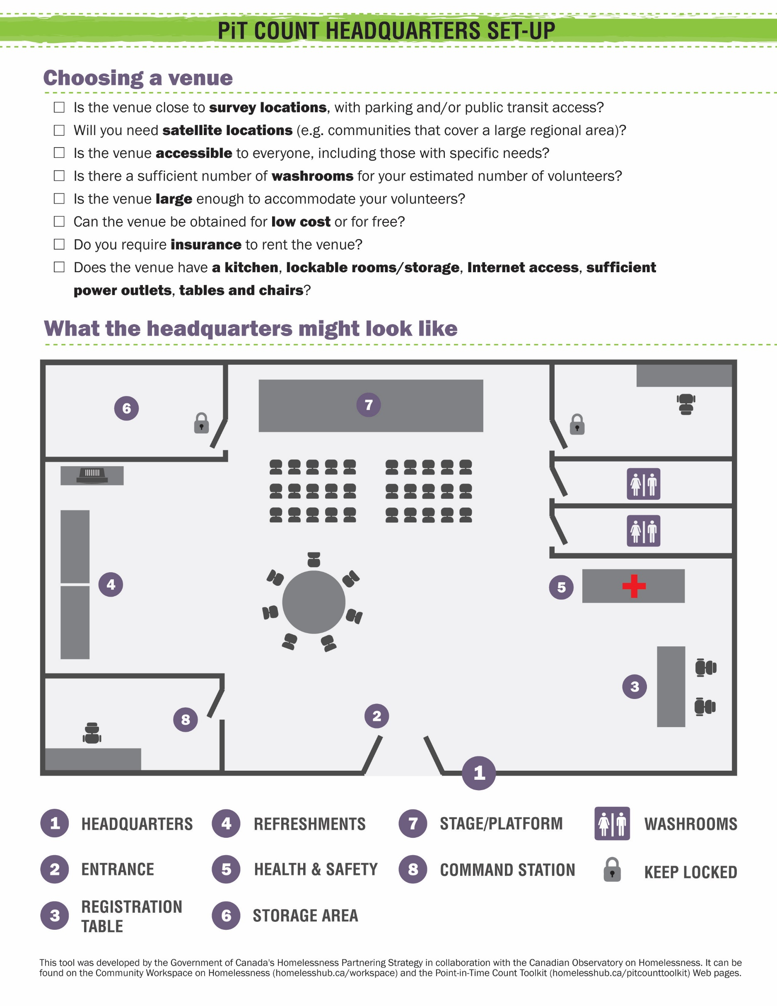

Area | Considerations | Equipment | Personnel
- Headquarters - General | - Will it be obvious to volunteers where to go?  - Who is in charge of waste/rubbish removal and recycling? Confirm with the venue.  - Does HQ feel inviting? Will it contribute to a positive experience for volunteers? | Microphone, speakers, markers, computers, projector, screen, tables/chairs, signage | See below.
- Entrance | - Do you have HQ volunteers/staff to greet volunteers and direct them to the registration table?  - Will volunteers be able to answer general questions and be responsible for lost and found items? | A copy of the agenda for the day/evening | Greeters, clearly identified by t-shirts, buttons, etc.
- Registration table | - Where will volunteers sign in and out?  - Do the HQ registration volunteers have access to a computer to keep track of volunteers and give them team assignments?  - Do they have access to the necessary volunteer forms?  - Will you distribute the surveyor kits and thank-you packages at the registration table? | Tables, chairs, laptops, Internet access, volunteer forms, surveyor kits (optional), thank-you packages, cellphones | Determine the number of registration volunteers/staff, depending on the size of the count.
- Refreshments | - Have you provided volunteers with light refreshments, water and warm beverages? (e.g.: coffee/tea, juice, water, cookies, granola bars) | Tables, chairs, coffee machine, carafe, glasses, plates | Volunteer/staff to monitor the station, answer questions – can be a greeter.
- Health and safety | - Have you created a safety/emergency plan?  - Who is responsible for first aid?  - What are the requirements of your insurance?  - Are the points of entrance and exit easy to find and accessible? | First aid kit, chair, table, blanket (as per emergency plan) | Consider having a paramedic or trained responder on site.
- Storage area  (locked room) | - Do you have a place to store completed surveys as volunteers return to HQ?  - Do you have a spot to store extra survey forms, tally sheets, supplies, honoraria and refreshments? | Computer | Responsible volunteers/staff should be carefully overseen by the coordinator or assistant coordinator.
- Stage/platform  (Optional) | - Have you identified an area to welcome the volunteers as a group? Provide a recap on training? Recap on safety? Have you created functional aisles? | Chairs, audiovisual equipment if needed | Volunteers to set up/tear down. Guest speakers if desired.
- Command  station | - Do you have a designated location for your HQ volunteers/staff to monitor team progress and take calls from teams as concerns or emergencies arise? | Cellphones, computers, contact/team lists, maps, volunteer lists | Volunteers/staff (may be your registration volunteers) should be carefully overseen by a count coordinator.

