HIFIS Tips and Tricks

Table of Contents

Maximize Support to Clients by Streamlining Admissions 3
Save Time During the Shelter Intake Process with the Booked-In Feature 3
Maximize Efficiency Using the Shelter Reservations Feature 4
Streamline Bed Availability 5
Link Clients Together in HIFIS to Support Families 5
Housing Loss Prevention 6
Reconnect Clients with Housing with the Housing Placements Feature 6
Provide faster links to housing with the HIFIS Housing Feature! 7
Increasing service coordination for people experiencing homelessness begins with the Calls and Visits Logs feature! 7
Increasing efficiency using the Block Operations feature 8
HIFIS can help front line workers act when there is an alert with the Service Restriction function! 8
Quality information is the foundation of effective services and evidence-based practice 8
How to Record Conflicts in HIFIS 9
How group activity demographics increase knowledge on clients’ needs 9
Connect your clients to services with the Directory of Services Module 10
Secure your Clients’ belongings with the Storage Module 10
Strengthening Relationships with Landlords in HIFIS 11
Support Case Manager Decision Making by Tracking Services 12
More Information 12

Maximize Support to Clients by Streamlining Admissions

HIFIS offers an easy to complete Admission Module that captures the information needed to support clients’ admission in shelters.
Using a Homelessness Management Information System (HMIS) such as HIFIS helps to personalize engagement with clients and complete the admission process faster. The intuitive module supports communities to create a seamless administration process when booking in or checking out a bed in a shelter. It also offers the possibility to create alerts as well as document actions and services provided to clients. In fact, the system can be tailored by setting up services and assigning them to the specific providers that offer them. Working together is easy with the embedded Bulletin module that supports instant communications between providers. Remember to think "mobile" since HIFIS can do it!
In addition to putting an end to time-consuming admission paperwork, with the right configuration, you can use the data and reports to focus on offering services to clients and measuring the progress of reducing homelessness.

Save Time During the Shelter Intake Process with the Booked-In Feature

Having clients describe their experience of homelessness during an intake process can be challenging for both clients and front line workers. Important details of a story can get lost if clients need to repeat information to different workers to access shelter services. The Booked-in feature in the Admissions module of HIFIS allows workers to see previous overnight stays. This module streamlines the intake experience and creates a seamless administration process to know the number of beds available in real-time. Workers can focus on being more client-centered and helping clients meet their needs instead of managing paperwork.

On a client’s first visit to a shelter (family book-in steps are also available):
- Create a client’s profile in the Client module.
- Book-in the client through the Admission module:
- Click on Front Desk
- Select the Admission module
- Click on the Add-Book-In button at the bottom of the page
- Fill out the required fields (note: a client’s profile has to be created through the Client module before booking in)
- Click on the Next button to move to the Bed Selection page (note: the service provider’s room and bed have to be set up prior to booking in a client)
- Assign a bed to the client among the available options (note: when a client is successfully placed into a bed, the bed icon will turn green)
- Once a client is booked-in, the Admissions module displays the client’s full name, the date and time they booked in, the current reason for service and the bed assignment
When a client is booking out of a shelter:
Clients can be booked-out of their bed by only clicking the Book-Out icon. For shelters that discharge all clients everyday, this process can be achieved by using the Block Operation module. This can save even more time!
When a client is returning in shelter:
Workers can access or edit the client’s book-in information by clicking the Display or Edit icons. Having information in advance in the system allows workers to put less pressure on clients to tell their story more than once. This is one way that shelters can become more trauma-informed.
The integrated HIFIS Help Centre provides an array of ‘’How tos’’ on the Admissions module and more.
You can find more information on the Admission Module in the HIFIS User Guide available on the Homelessness Learning Hub.

Maximize Efficiency Using the Shelter Reservations Feature

The shelter Reservations feature in HIFIS gives service providers the ability to work together to manage shelter book-ins more efficiently in a system of care as well as plan for the night ahead where they expect a client to return for service. This allows for better service delivery by creating more seamless transitions between providers or between shifts within the same shelter, both reducing the trauma that clients can experience if they have to repeat information during repeat intake processes.

Reservations
Front line workers can use the shelter Reservations feature in the Admissions module to reserve shelter beds for clients before their arrival. For example, outreach workers can refer clients to a specific shelter provider. Reserving a bed in these situations helps shelter providers fast-track their book-ins when the client shows up for service. Details shared during the prevention and diversion conversation do not have to be repeated, allowing for more seamless service.
The shelter Reservations feature in HIFIS also allows planning stay days, weeks or months ahead. Perhaps your shelter has access to beds on-site that are for people who need help with detox. A client can be receiving treatment at a detox centre and be in need of a bed at a certain time, whether it is on the same day or in a month’s time.
For returning clients, making a reservation when client leave for the day can help the shelter plan ahead for the night and allow for the client to set aside their belongings securely. In HIFIS, service providers can easily record clients’ personal items through the Storage module, if this service is offered at their location.
To create a reservation on a client’s first visit to a shelter:
- Create a client profile in the Client module
- Create a reservation in HIFIS through the Admission module by:
  - Clicking on Front Desk.
  - Selecting the Admission module.
  - Clicking on the Reservation tab and then the Add Reservation button.
  - Entering the client’s information.
  - Clicking on the Next button to move to the Reservation – Bed Selection page (Note: The service provider’s room and bed have to be set up prior to booking in a client).
  - Assigning a bed to the client among the available options. (Note: when a bed is selected, the bed icon will turn green. Beds with pending reservations will be identified with a symbol)
  - Tips: Hovering over beds with pending reservations will provide the reservations’ information.
  - Clicking Save at the top of the page.
  - The client’s reservation will show up in the Reservations’ tab.
- Once the reservation is completed, booking-in the client in shelter is simple:
Click on the Book-in icon next to the client’s reservation from the Reservations tab once the client arrives in shelter to book-in. (Note: once the client is booked in from this page, the reservation will disappear).

Streamline Bed Availability

For front line workers, managing both client intakes and shelter accommodations can sometimes be a challenge. Streamlining bed assignment should be then quick and easy. If a shelter has issues with rooms and/or beds such as a broken bed, front line workers can move clients between rooms and beds without booking them out. This can be done in a few steps through both the Reservations and Booked In tabs by:

- Clicking Front Desk and clicking on the Admissions module.
- Clicking the Manage Rooms and Beds button at the bottom of the page.
- Selecting the client you want to move.
Note: HIFIS Administrators can easily change the status of a bed from active to inactive through the Service Provider’s module in Administration. See page 95 of the HIFIS User Guide to follow the steps.
- Selecting the bed you want to move the client into.

Speed up your research by consulting a summary of the information entered about bed availability through the tab Bed Availability as part of the Admissions module. In one glance, service providers have access to the occupancy rate in real-time, the number of available beds and the total number of beds. Where shelters are using the reservations feature, the number of clients who are waiting for an intake is also displayed. View the Admission section in the HIFIS User Guide on page 36.

Link Clients Together in HIFIS to Support Families

According to the National Shelter Study (2005 to 2016), in 2016, the occupancy rate at family shelters was 85.7%, a 27% increase since 2005. In addition, the estimate for a typical shelter stay by a family with a single stay was 24.9 days. This is nearly twice as long as the estimated length of stay by an individual (13.2 days).
In order to support the flow of families through your housing and homelessness response system, and to have crucial data of families experiencing homelessness, HIFIS links clients together to create families.
To create a Family in HIFIS:
- Click on Front Desk
- Select Clients
- Click on the client in question
- Under Client Information click on Family
- Click on Start New Family
- You can either Add Member if the client already exists in HIFIS or Create and Add Member
- Add all information necessary and save
Families (or Family Members) appear in different modules in HIFIS, such as Admissions, Case Management, Housing Placement, and Turn Aways.

Housing Loss Prevention

Did you know that HIFIS 4 can support Housing Loss Prevention? HIFIS 4 is a software that allows you to see real-time changes in a client’s profile and helps service providers with their day-to-day operations such as providing supports to individuals at risk of housing loss.

To create a Housing Loss Prevention Record, the client must have a Housing History record that does not have an End Date. Similar to housing placements, once a Housing Loss Prevention Record is created, HIFIS users can record follow-ups with the clients and any related subsidies.

To record Housing Loss Prevention, follow these steps:
- In the Client List page, select the client record you want to add a Housing Loss Prevention Record to by clicking the name of the client.
- In the Client Vitals page, click the ‘’Client Information’’ menu and select ‘’Housing History’’.
- In the Client Housing History page, click ‘’Add Housing Loss Prevention’’. Note that a Housing History Record must be created in order to create a Housing Loss Prevention Record.

Reconnect Clients with Housing with the Housing Placements Feature

Every individual and family experiencing homelessness deserves a safe and affordable place to call home. Helping clients achieve housing - moving from the streets or shelter into the best permanent housing option based on their needs and preferences - represents a challenge in every community across the country.

The Housing Placements feature allows service providers to support individuals and families with their housing plan. Using HIFIS, case managers can record progress throughout the re-housing process: searching for housing, securing housing, setting-up new housing and initial housing stabilization. The Housing Placements feature provides shelter workers with key information about shelter clients, such as the number of viewings the client has had and the outcomes of these housing attempts. Workers can then use this information to refine the next steps in the housing plan, including revisiting needs and preferences. The Housing Placements feature already has a number of standard fields, but is also customizable.

The Housing Placements feature can show a dynamic picture of progress with a housing plan over time. To add housing placements:

- Click on the ‘’Front Desk’’ menu ‘’Housing’’.
- Click ‘’Housing Placements’’ under the ‘’Housing’’ Module.
- View listed Housing Placements or ‘’Add Housing Placement’’.
- Fill out the fields
- Click Save!

Once entered, the information is available in the Housing Placements section through the Client Management section in the client’s profile.

Provide faster links to housing with the HIFIS Housing Feature!
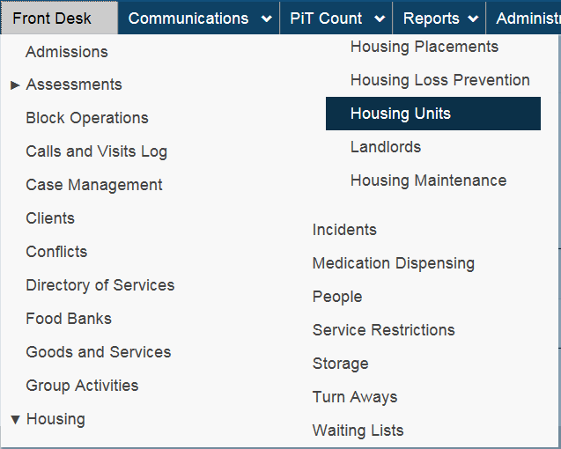
The HIFIS Housing feature can help improve the quality of client services and provide faster links to housing! Through HIFIS, a community can add a housing placement in a clients’ file, as well as maintain an inventory of housing units and a list of landlords. The information gathered through this software can help communities manage vacancy and rental information regarding housing. In addition, the information collected through HIFIS can also be used for housing community reports. To access
the HIFIS Housing feature, please follow the following steps:
1. Click on the “Front Desk” menu.
2. Select the “Housing” module and then select “Housing Units”.
3. Select “Add Housing Unit” at the bottom of the page.
4. Enter the information related to housing unit (note that a landlord must already be entered in the system to complete this field. This can be done under “Front Desk” > “People”).
5. Click on the “Address Tab” to enter the address of the unit.
6. Click Save.
7. You can then go in the client file and add the Housing Unit to their case.

By increasing the availability of data, communities and funding partners are better positioned to make decisions about which services should be provided to people experiencing homelessness in their community.

Increasing service coordination for people experiencing homelessness begins with the Calls and Visits Logs feature!
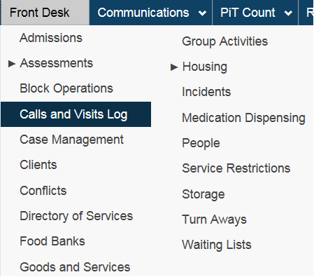
It can be challenging to track and provide follow-up supports to people experiencing homelessness.
The Homelessness Individuals and Families Information System (HIFIS) Calls and Visits Log is a module that allows case workers to record contacts and
communications that a client has and/or receives during or after a service provider stay. The correspondence recorded can be used to create a Case
Management to monitor and coordinate services for a client. To access the module, select Calls and Visits Logs Module under the Front Desk Menu!
You can visit the Demo Website to test the module.

Increasing efficiency using the Block Operations feature
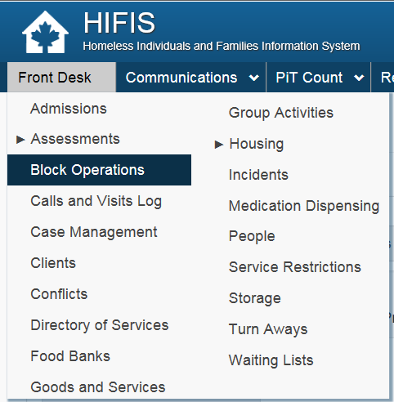
Some shelters require that all clients be booked out every morning. Booking out clients one by one can be time consuming. To help save time, shelter bed administrators can use the Block Operations module to book out a group of clients after a service provider stay all at once.
To access the module, go to the Front Desk menu, select Block Operations, select the service provider and expand the list to see the full list of clients. Click the checkbox of the clients you wish to book out and select Book Out Selected Clients. To test the module, visit the Demo Website. The Block Operations module is the smart way to go!

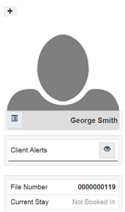
HIFIS can help front line workers act when there is an alert with the Service Restriction function!
The HIFIS Service Restriction function helps service providers track information if a client is acting in an intimidating way, does not respect the rules set by the service providers, has a court order or is ineligible for a service. The HIFIS Service Restriction indicates client services restrictions, the duration of the restriction, as well as the reason why a client is restricted from a service. When a client is restricted from a service, a Client Alert appears under their profile. For example, in HIFIS, a client can be restricted from the following modules: Stays, Food Banks and Goods and Services.
To record a service restriction:
1. Click on “Front Desk”.
2. Select “Service Restrictions”.
3. Cick ‘’Add Service Restriction’’.
4. Enter the information
6. Click Save!
7. The client alert will then appear in the client file

Quality information is the foundation of effective services and evidence-based practice
To help capture timely and accurate information, HIFIS offers an easy-to-use Case Management Module that allows service providers to document and edit files. With HIFIS 4, updating or correcting a file is fast as it provides you with real-time documentation that helps you and your clients. To edit or delete a document:
- Search for the client in the ‘’Client Search Field’’.
- Click on the client’s name.
- Under ‘’Client Management’’, click on ‘’Case Management’’.
- Click on the Edit icon of the Case Management.
- Select the Documents tab.
- Under the Actions column, click on the garbage bin next to the document and click on delete.

Security for best practice: Granting system user rights is an important decision. As a best practice, we encourage you to carefully determine who needs access to which data. One way of ensuring this is to create an access request procedure so users can request access to information on an ongoing basis to complete tasks. All of this can be done in HIFIS!
How to Record Conflicts in HIFIS
The HIFIS Conflicts module allows service providers to record and document conflicts, disputes and disagreements between two individuals (clients and/or staff). The module gathers information such as the type of conflict (e.g., physical, sexual and psychological), the incident, the intensity of conflict and the aggressor. By identifying conflicts with clients, community partners can use the module to inform the delivery of services to clients, as well as activity planning to ensure clients have access to the appropriate supports within the community.
To enter a conflict in HIFIS:
- Click on the ‘’Front Desk’’ menu.
- Select the module ‘’Conflicts’’.
- Click the ‘’Add Conflict button’’.
- Enter the information in the fields.
- Click Save!

Note that the system will not allow a user to select two victims for a record.

How group activity demographics increase knowledge on clients’ needs
The HIFIS Group Activity module allows service providers to create group activities for clients, such as support groups and outreach or meal programs. This module keeps track of individuals who attend group activities as well as their demographics, increasing the understanding of client participation. To create a group activity:
- Click on the ‘’Front Desk’’ menu.
- Select the module ‘’Group Activity’’.
- Enter the information in the fields.
- Click Save!

The Group Activity module can also support intervention plans by allowing service providers to have access to a client’s group activities list, whether they are booked into a shelter or not. To access the Group Activity list of a client:
- Click on the ‘’Front Desk’’ menu.
- Select the ‘’Client’’ module, then select the client.
- Under the ‘’Client Management’’ section, click on ‘’Group Activities’’. A list of all group activities attended by the client will display.

Once the group activity is created, service providers can list the attendees and the organizers, add comments and replicate the activity at a later date.

Connect your clients to services with the Directory of Services Module

The Directory of Services connects clients faster to key services in the community and enhance the community’s service capacity.

HIFIS supports community partners (e.g. clinics, schools and daycares) or organizations that provide services (e.g. mental health, food bank, or detoxification) through the Directory of Services module. Just like creating your own ‘’yellow pages’’!

Service providers can record the location and contact information of partners in the Directory of Services. This information can be used in other modules to provide additional information on locations of services offered such as a pharmacy for when medication records are added or a food bank for when a food bank transaction is added. It helps caseworkers to determine which services are available to the clients needs.

When aggregated, this information can also allow to track the volume of interactions with partners from across the community, including the origin of clients using shelters and the different partners from which clients receive services. This module can then help support decision-making in the development of strategic partnerships within the community.

To add a location to your Directory of Services:
- Click on the ‘’Front Desk’’ menu.
- Select the module ‘’Directory of Services’’.
- Click on the ‘’Add Place’’ button.
- Enter the information in the fields.
- Click Save!

To quickly identify the location of a partner or specific services offered, use the filter option in the Directory of Services module by entering a place type and/or services offered. A list of all recorded places that offer the services will be displayed.

Secure your Clients’ belongings with the Storage Module

Storage solutions help bring stability to individuals experiencing homelessness. In HIFIS, service providers can easily record clients’ personal items through the Storage module, if this service is offered at their location.

For individuals experiencing homelessness, simply being able to safeguard belongings, such as clothes or documents that can be hard or expensive to replace, even if it is for a short period, can lift a big weight off their shoulders. The storage feature allows service providers to do just that.

To add a storage item:

- Click on the ‘’Front Desk’’ menu.
- Click on the ‘’Storage’’ module.
- At the bottom of the page, click on ‘’Add Storage Item’’.
- Fill out the fields.
- Click Save!

Once entered, the information is available in the Storage section through the Client Management section in the client’s profile.

Strengthening Relationships with Landlords in HIFIS

Building strong relationships with landlords can be a catalyst to increase the range of housing options for clients. However, communicating with landlords and keeping track of them, particularly with those who are compassionate with people with lived experience of homelessness, can be challenging.

To support this, HIFIS offers a centralized database that documents and recording landlords that housing and homelessness sector workers are in contact with.

There are many different ways workers can track housing resources in HIFIS, such as creating a network of landlords in the People module. This function allows linking a landlord to a Housing Unit, therefore facilitate the liaison between clients with housing options of certain landlords.

When creating a Housing Unit, you can attach a landlord to it. If the landlord is not in the system, follow these steps to add a new record:

- Click on the ‘’Front Desk’’ menu.
- Select the ‘’People’’ module.
- Click on “Add Person”.
- Enter all information related to the person.
- Under roles, select ‘’Landlord’’ and any other roles.
- Save!

Note: To view all landlords, make sure to select ‘’No’’ for Only available to this service provider, in the filter option.

If the person already exists in the system, it is just a matter of adding a role. Follow these steps:

- Click on the ‘’Front Desk’’ menu.
- Select the ‘’People’’ module.
- Click on the person’s name.
- Under the vitals tab click on edit.
- Add the Landlord role.
- Save!

Support Case Manager Decision Making by Tracking Services

Case Managers help individuals and families experiencing homelessness to connect with various support services. HIFIS can help record each transaction (e.g. bus tickets, food, clothing) to capture a history of client supports received. An overview of services can assist in decision-making and pinpoint next steps. Add an express Good or Service in HIFIS by:

- Clicking on the “Front Desk” menu.
- Selecting the “Goods and Services” module.
- Selecting “Express Good” or “Express Service”.
- Enter the information.
- Click Save!

HIFIS has the ability to record a wide range of transactions to keep track of clients’ service plans, but also any one-time or ongoing subsidies provided to clients.

More Information
For any questions, please contact the HIFIS Client Support Centre by email or by phone at 1-866- 324-2375 or visit the Demo Website for help. For more HIFIS information, visit the HIFIS Website.

