Everyone Counts: The 2020 Coordinated Point-in-Time Count

10 Tips for managing difficult conversations during the survey
1

Try not to take things personally
People may be reacting to you, but remember, they are not necessarily upset with you personally.
2

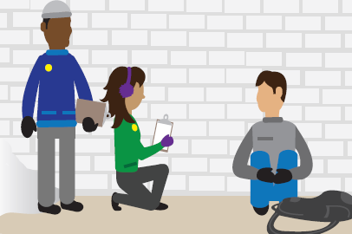
Manage your body language
Be aware of your facial expressions, so you can outwardly show a calm demeanor. Make sure to use a non-threatening position, and maintain physical distance. By showing attentiveness, you can help calm an upset person.
3

Project a positive attitude
Smile and speak with a calm tone.
4

Use appropriate phrases when needed
Do not criticize the survey participants but do acknowledge their perceptions.
5

Focus on the survey
Remaining focussed on the task will help you stay detached and less emotional when aggression or unpleasantness is directed at you.
6
Avoid conversations that involve controversial topics
Often when a person initiates a negative message, they are trying to trigger a response from you. Do not respond, and stay focused on the survey.
7

Silence can be good
When a question comes your way, embrace the silent pause that will come along with it. Take the time you need to process your response.
8

End the conversation
Make a statement to summarize and wrap up, then say you have to continue to survey other people. Provide the resource card.
9

Practice the survey
Practice the survey before conducting the real one.
10

Excuse yourself
Sometimes the best approach to difficult people is just to smile politely and remove yourself from the conversation at the first opportunity. A simple “Excuse me” or “I’m sorry to have bothered you” will suffice. There is usually no need for explanation and you can walk away.
This tool was developed by Employment and Social Development Canada in collaboration with the
Canadian Observatory on Homelessness. It can be found on the Homelessness Learning Hub (homelessnesslearninghub.ca/courses/point-time-counts) and the Point-in-Time Count Toolkit
(homelesshub.ca/pitcounttoolkit) Web pages.

